German Supply Chain Due Diligence Act Compliance for Log360
Tagline: Support LkSG compliance with centralized monitoring and reporting from Log360.

Overview
The German Supply Chain Due Diligence Act (LkSG) Compliance extension for Log360 helps German companies subject to the LkSG meet IT-related risk management, vendor access monitoring, and audit logging obligations for their supply chain due diligence programs.
Log360 monitors access by third-party suppliers and service providers to corporate systems, cloud platforms, and sensitive data repositories, providing security teams with visibility into third-party risk indicators. Compliance teams can track supplier access events, detect anomalous behavior, and generate documentation to support LkSG risk assessment and reporting obligations to BAFA.

Key Features
- Generate audit reports covering LkSG-relevant IT controls including third-party access monitoring, vendor authentication events, and supply chain risk indicators.
- Monitor access by suppliers and service providers to corporate systems and cloud environments, detecting unauthorized access and policy violations in real time.
- Configure threshold-based alerts for LkSG supply chain risk events such as unusual vendor access patterns, unauthorized data exports, and privilege escalation by third parties.
- Export compliance documentation in PDF and CSV formats for BAFA due diligence reports and internal supply chain risk governance reviews.
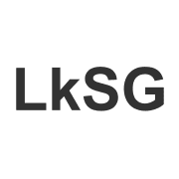
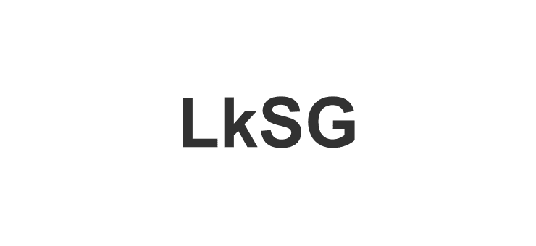

Screenshots
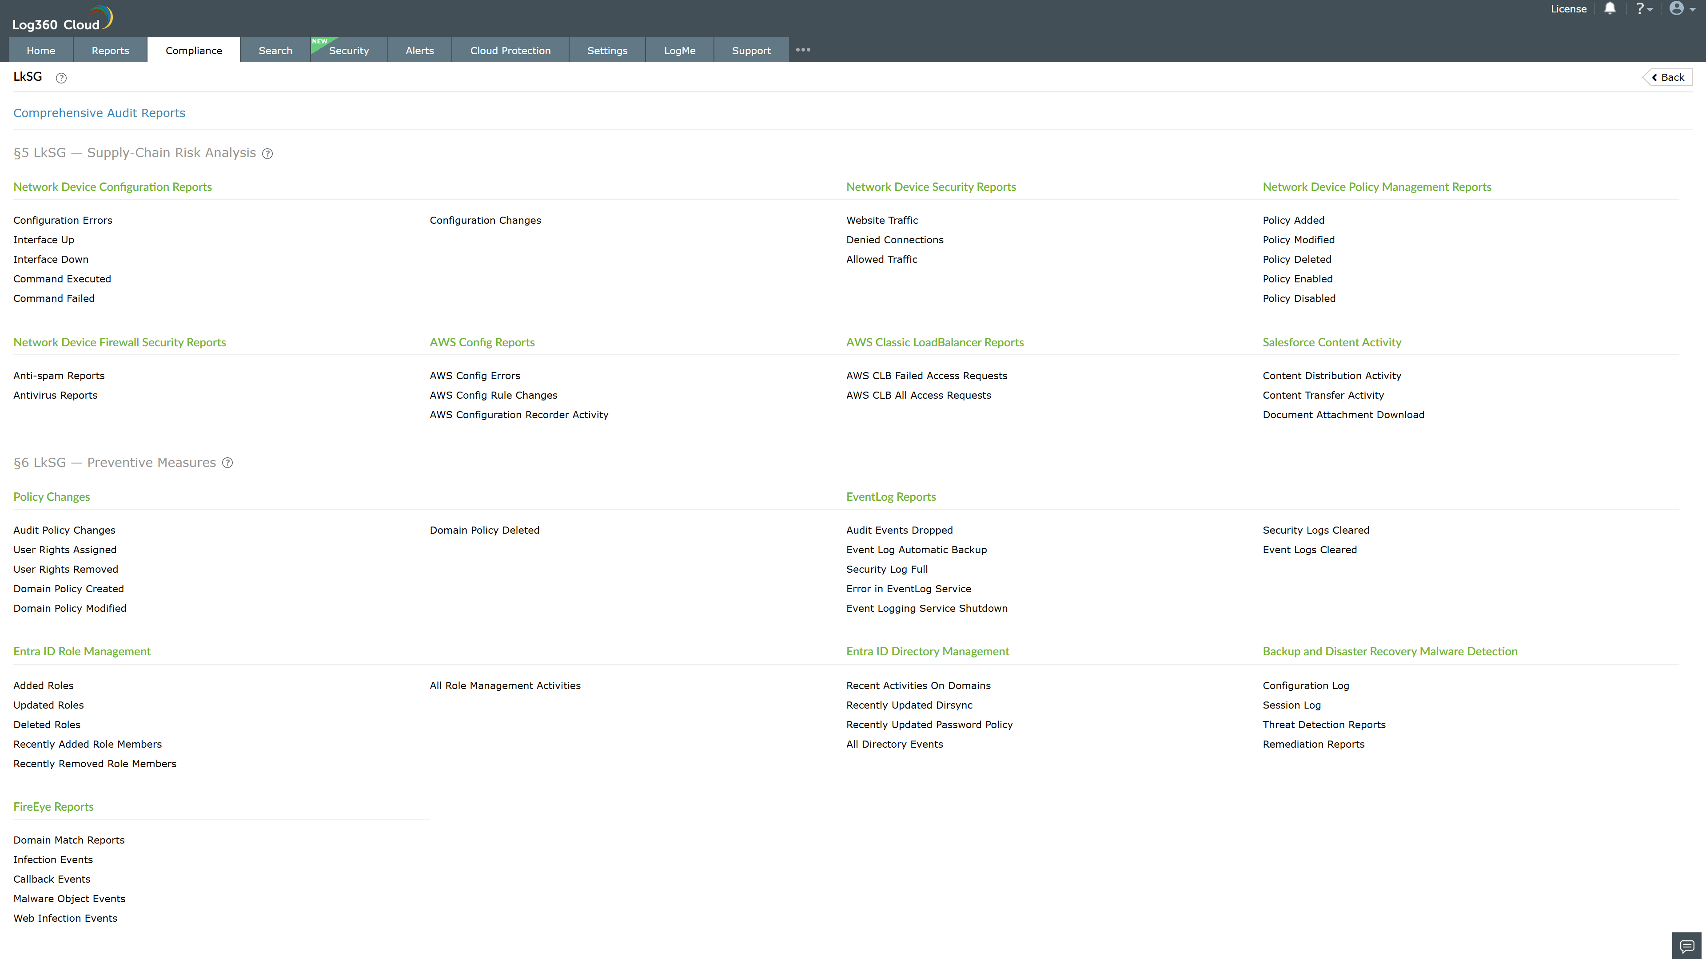
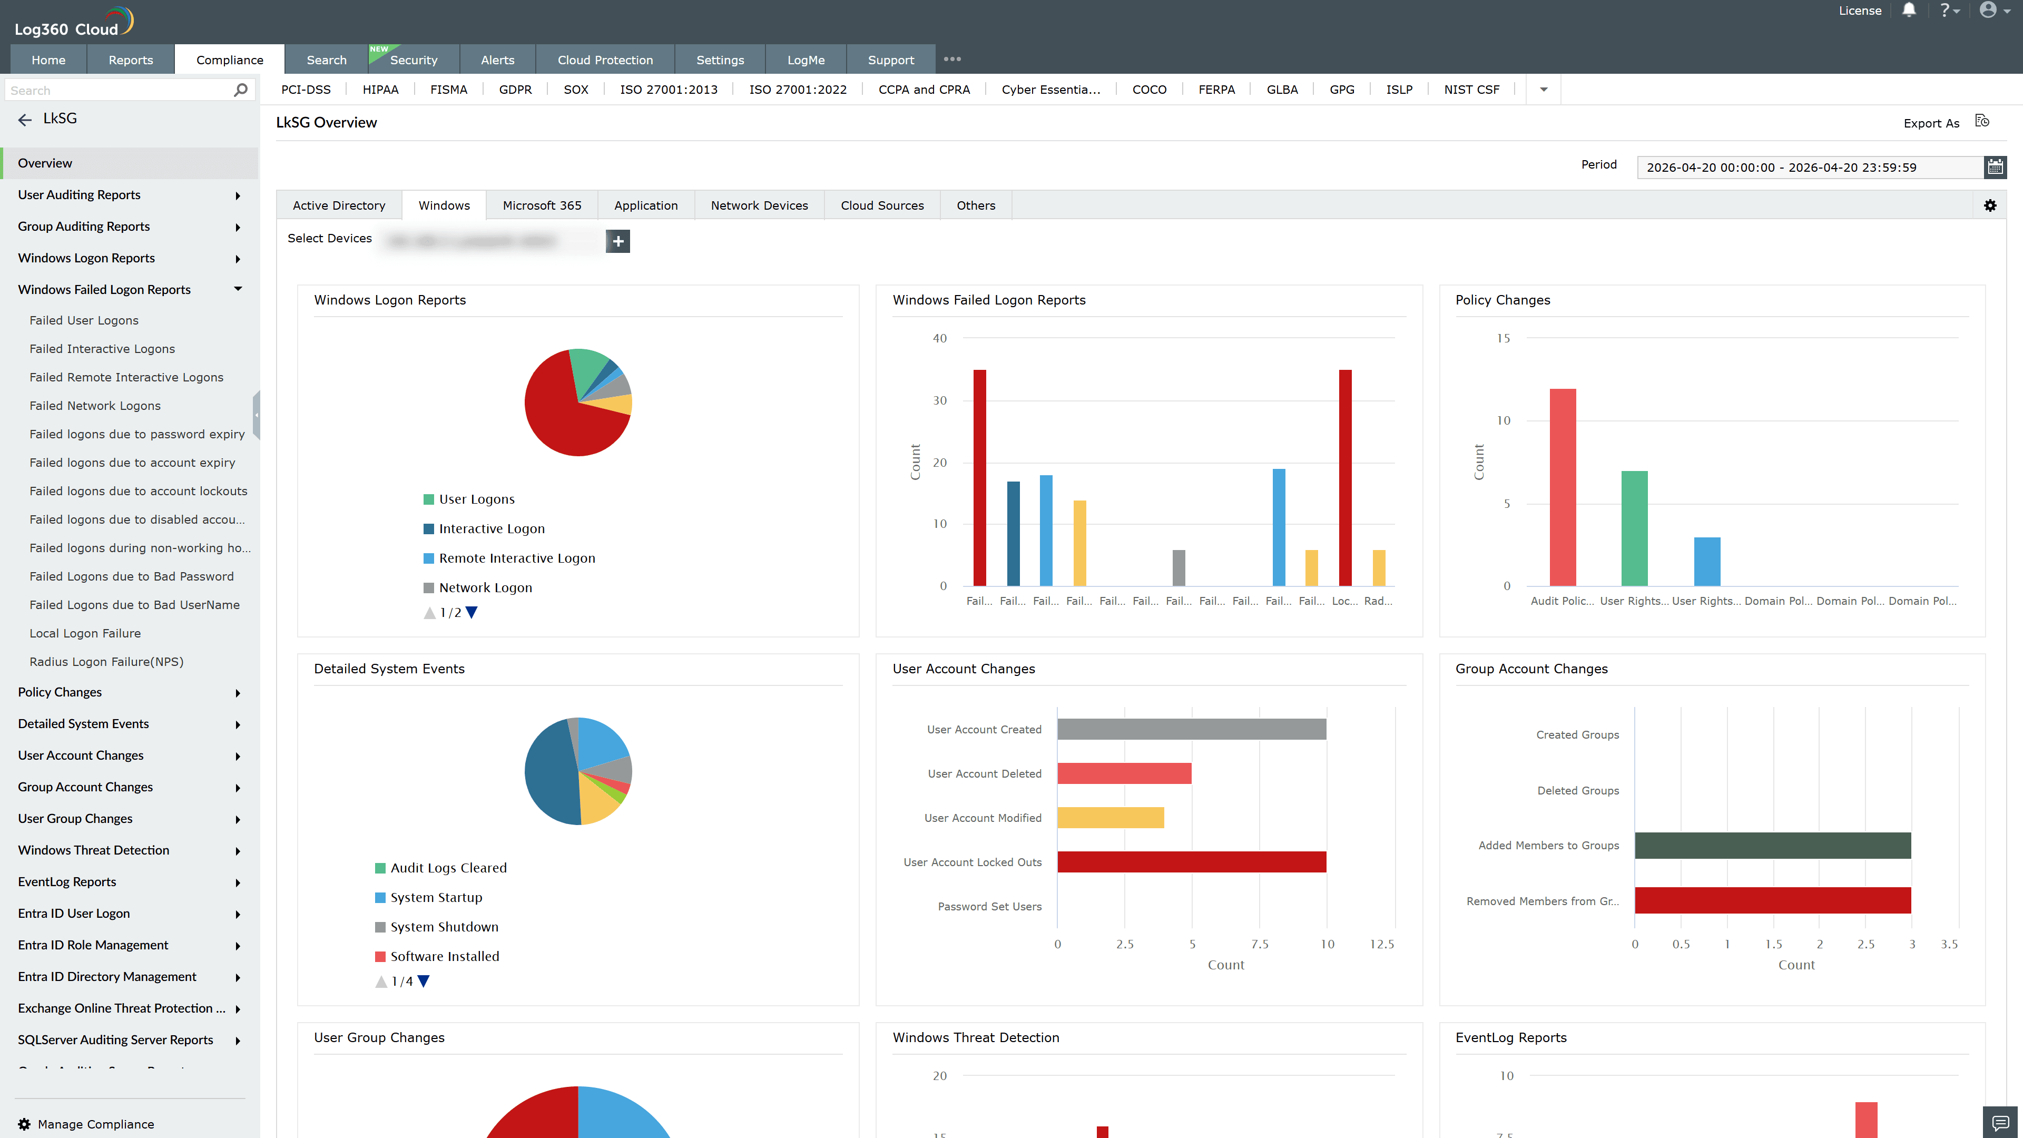
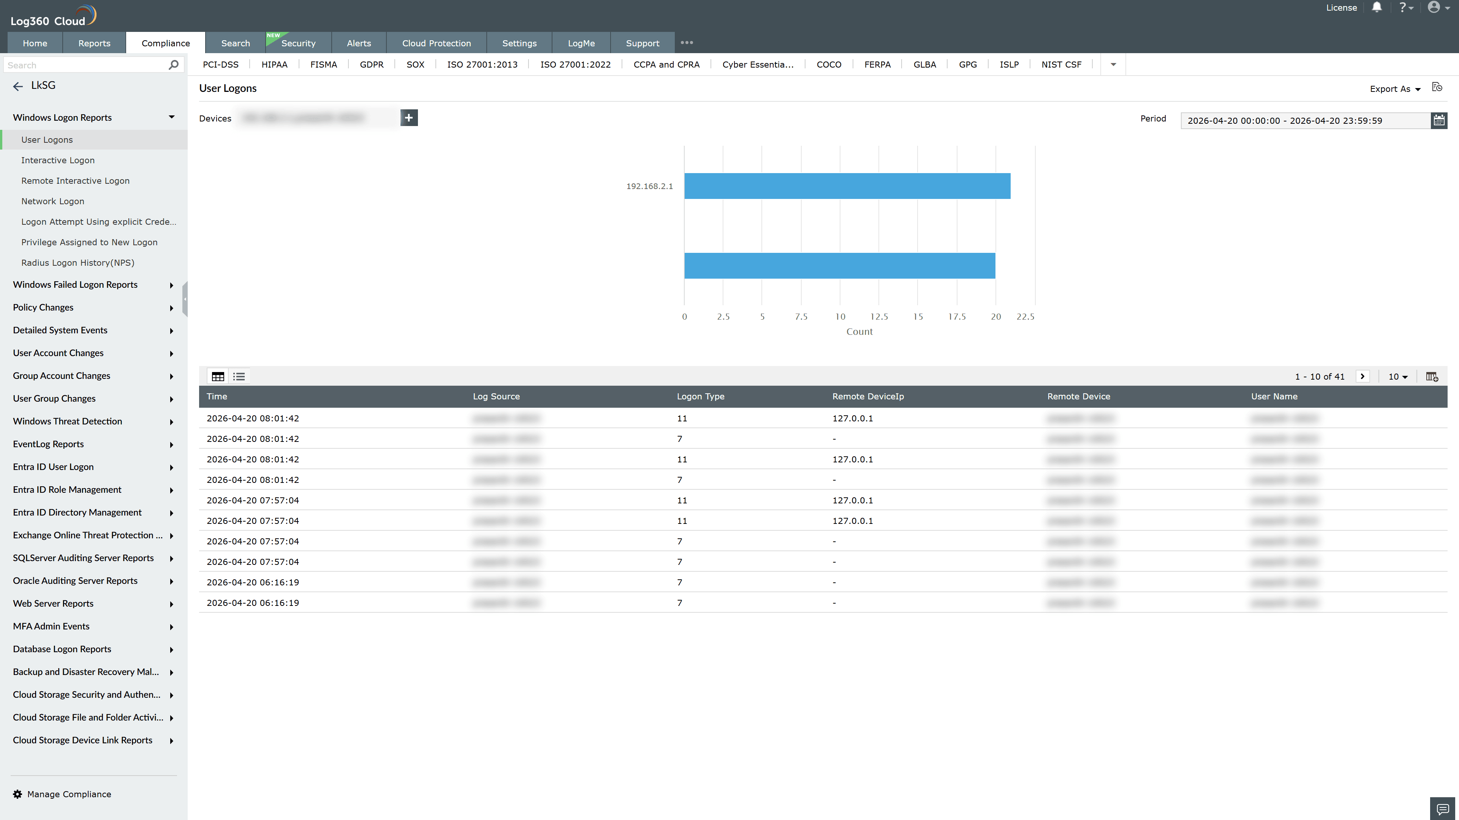
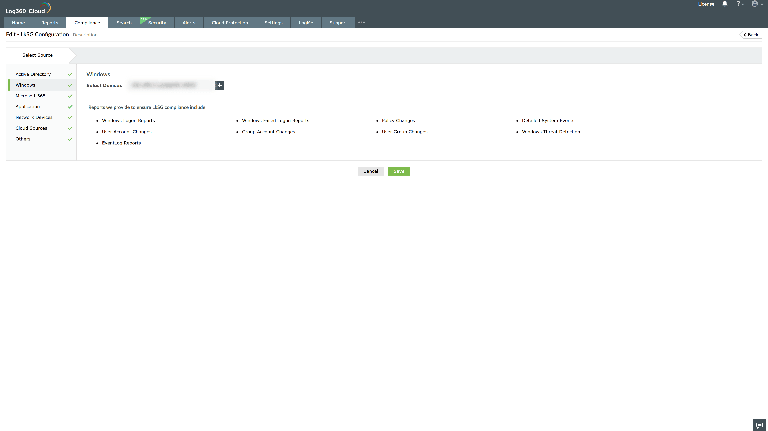

Valid Submission : Yes
Supported Editions : Free, Basic, Standard, Professional, MSSP
Help Document : https://www.manageengine.com/log-management/help/integrations/compliance-extensions.html
Help Video : Not provided
Tags : Log360, Compliance, Privacy monitoring, Data privacy, Regulatory compliance
Supported DCs : US, IN, JP, CA, AU, UK and EU
Privacy Policy:
Terms of Service:
Release Notes:
Predefined reports for the German Supply Chain Due Diligence Act (LkSG) Compliance

